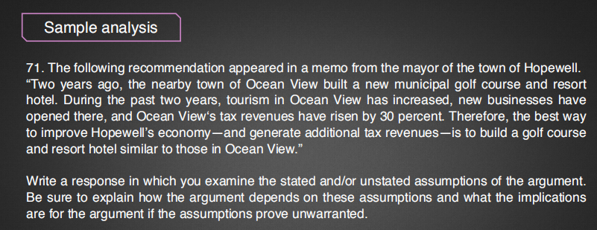

因果类：强加因果

类比类：个体→个体：差异性

CA：别的更适合的发展能带来更大的效益

时间类：2年之后可能高尔夫不再火爆

证词类：无

条件不充分： 税收的提高可能不一定是因为利润增加，也可能是比例变高，不能单单从这说明经济水平变好。

In this statement, the mayor believes that to build a golf course and resort hotel similar to those in Ocean view is the best to improve Hopewell's economy—and generate additional tax revenues. To support her reasoning, the mayor cites the following evidence. Because Ocean View, the nearby town, built a new municipal golf course and resort hotel, the tourism, business as well as its tax revenue then increased. At first glance, the argumentation seems plausible to certain degree. Unfortunately, with a detailed analysis the readers could still identify some serious logical fallacies and inappropriate assumptions that could undermine the chain of reasoning in the statement.

The first implied assumption that needs to be examined is whether building a golf course and resort hotel is the best way to improve economy. Even if Ocean View's tax revenue increased because of a golf course and resort hotel, nothing can prove this is the best way for Hopewell to enhance economy. There even exists possibilities that because Ocean View is near around Hopewell, it is useless for the latter to do the same thing, unless Hopewell can beat over the previous one. Moreover, other ways might be more appropriate for Hopewell, if Hopewell is known for history, preserving museum can be considered as a much better choice, which is bound to bring numerous tourists and profits. Therefore, it is unreasonable for the mayor to suggest that building a golf course and resort hotel is the best way to improve economy.

The second implied assumption that needs to be examined is that whether the economy increased in Ocean View just due to the golf course and resort hotel. Perhaps the mayor proposed an oversimplified causal relationship analysis by carelessly or deliberately ignoring the fact that there should exist other factors which might lead to the same consequence. If Ocean view developed the construction of the Central Business District or exploited a new natural scenery at the same time, the level of revenue would also boast to a large degree. There may exists chances that it were these thing that enhanced Ocean View's economic level, thus the reasoning might probably be largely weakened. In a word, the argumentation may have some fallacies that can't support the idea.

The third thing that needs to be checked is that whether the mayor ignored the difference between these two towns, which might greatly moderate the comparison. It is likely that Hopewell have no area for a municipal golf course or great view for a resort hotel, implying that it is impossible for Hopewell to develop economy by the same method. If the mayor insists on this, the cost will be out of imagination. What's more, the income of Hopewell's citizens has not been taken into account, which may be not able to afford the entertainment of golf or resort hotel. If this is true, nothing is feasible.

All in all, the reasons cited by the mayor cannot well support her argumentation in the memo as she expects.